

Student Full Name
Nicolas Anibal Pizarro Puebla
Student Number
2026491
Module Title
Strategic thinking
Assessment Title
CA 1 - Capstone Project Proposal
Lecturer/Supervisor
Taufique Ahmed
Assessment Due Date
25-10-2026
Date of Submission
25/10/2026
Assessment Cover Page
Use of AI Tools
I acknowledge the use of ChatGPT to help interpret the assessment requirements, structure the project proposal, draft and revise English text, explain methodological options and locate the official dataset source. Relevant prompts, outputs and my evaluation of the assistance are documented in this document. I take responsibility for reviewing, understanding and verifying the submitted content.
Delegation
I used ChatGPT to help understand the assessment requirements, organise the proposal, draft and shorten text, and explain methodological options. I used these explanations to compare approaches and select a manageable project scope. I retained responsibility for the project decisions and reviewing the proposed content.
Description
I asked ChatGPT to shorten the proposal paragraphs to help meet the 1,000-word limit, show Gantt chart examples so I could understand how to create a project timeline, and assess whether a dataset with 8,760 rows and 118 columns was suitable for a year-long project. These prompts supported concise writing, timeline planning and an initial assessment of dataset suitability.

Discernment
I accepted the shorter introduction because it preserved my main ideas and helped meet the 1,000-word limit. The Gantt chart examples clarified activity durations, overlaps and milestones, but their illustrative dates require adjustment to the academic calendar. I treated the dataset assessment as preliminary advice: 8,760 rows and 118 columns suggest potential, but suitability still depends on data quality and reliable counters.
Diligence
I acknowledge ChatGPT’s assistance with drafting and shortening proposal text, explaining Gantt charts, discussing dataset suitability and reviewing the Scope. I document relevant prompts, outputs and screenshots in the appendix. Before submission, I will check the word count, timeline and references. I will distinguish preliminary advice from verified findings and illustrative dates from confirmed deadlines. I remain responsible for understanding and verifying the submitted content.

References
Dublin City Council (n.d.) 2025 Pedestrian Footfall DCC. Available at: https://data.gov.ie/en_GB/dataset/dublin-city-centre-footfall-counters/resource/ca145381-cedf-475a-9b96-6e43b76c8a98 (Accessed: 14 October 2026)
Dublin City Council (n.d.) Pedestrian Footfall DCC. Available at: https://data.smartdublin.ie/dataset/dublin-city-centre-footfall-counters (Accessed: 14 October 2026).
Appendix: AI prompts and outputs
A1
AI tool: ChatGPT
Date: 14 October 2026
Purpose: To shorten the introduction to fit the proposal’s word limit.
Exact prompt — original Spanish:
“intenta por favor ir acortando los párrafos para que logremos llegar a las 1000 palabras”
English translation:
“Please try to shorten the paragraphs so that the complete proposal fits within 1,000 words.”
Relevant AI output — extract:
“Pedestrian activity in Dublin City Centre varies by location, day and time, creating challenges for retail and hospitality planning. This project proposes analysing historical pedestrian counts and developing a predictive model to estimate future footfall. The findings could help local businesses plan staffing, stock levels and promotional activities according to expected pedestrian activity.”
My evaluation and use:
I accepted the shorter introduction suggested by ChatGPT after it reviewed my original paragraph because the revised version was clearer and more concise, retained my main ideas and helped me stay within the assignment’s 1,000-word limit.
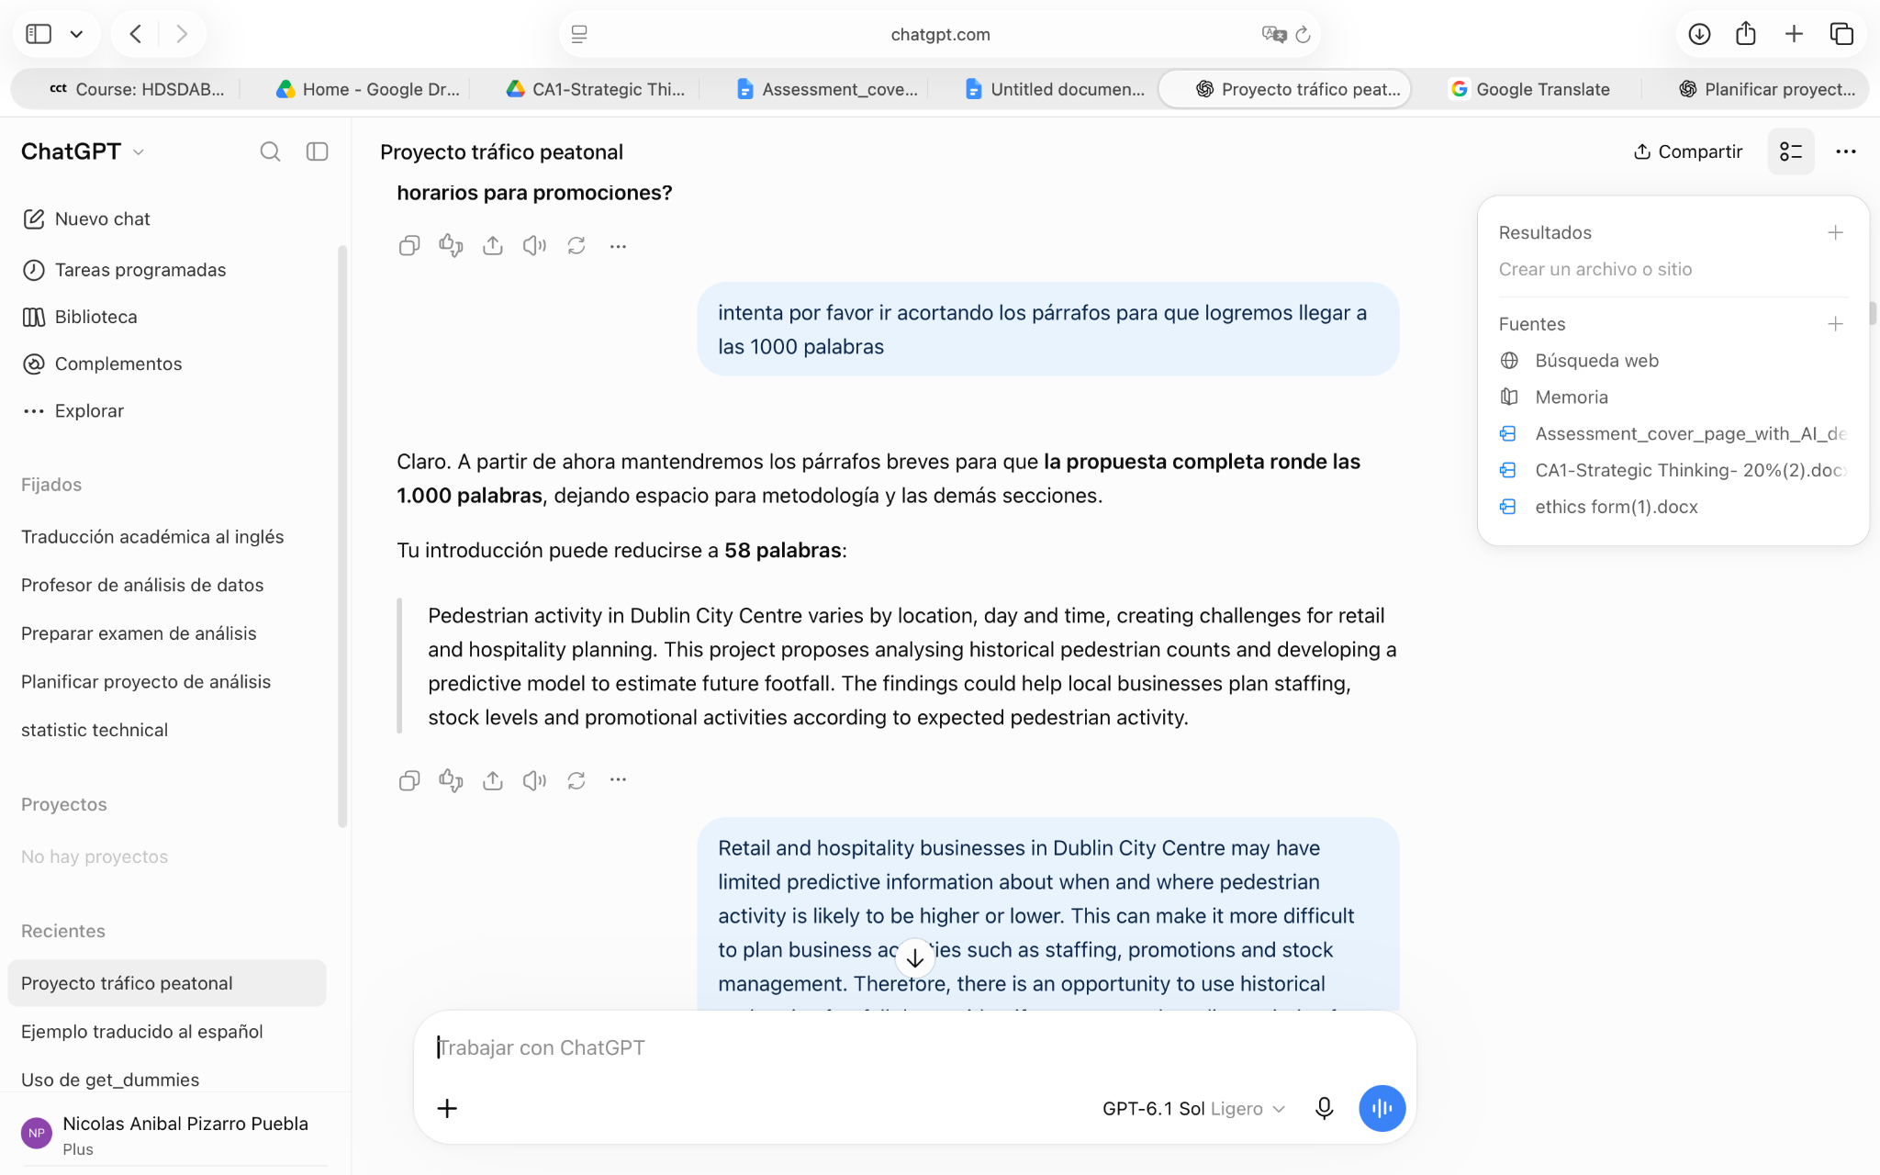

A2
AI tool: ChatGPT
Date: 14 October 2026
Purpose: To understand how to create a Gantt chart for the project timeline.
Exact prompt:
“could you show me some Gantt chart examples so I can lear how to make one ?”
My evaluation and use:
The explanation and examples helped me understand activity durations, overlapping tasks and milestones. I will use them as guidance for creating my project timeline. The example dates were illustrative and will not be treated as confirmed academic deadlines.
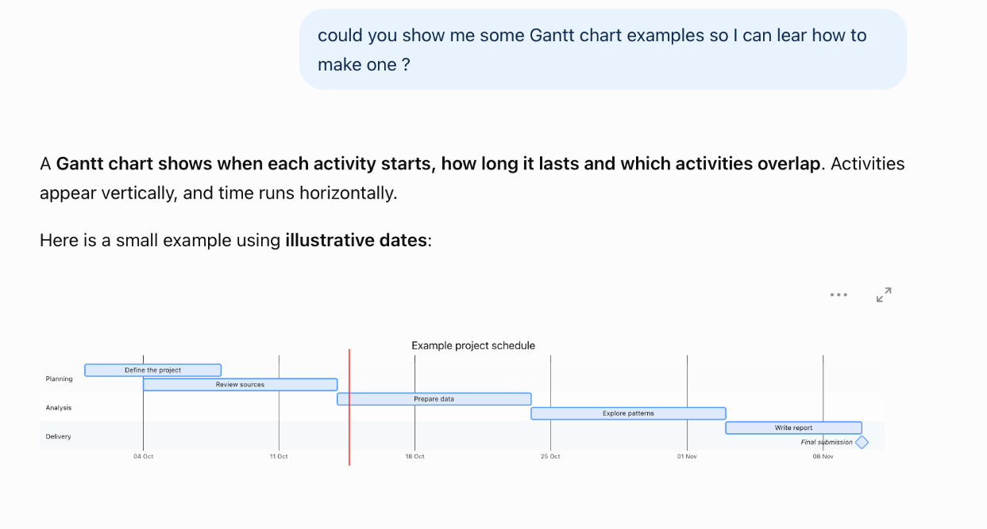

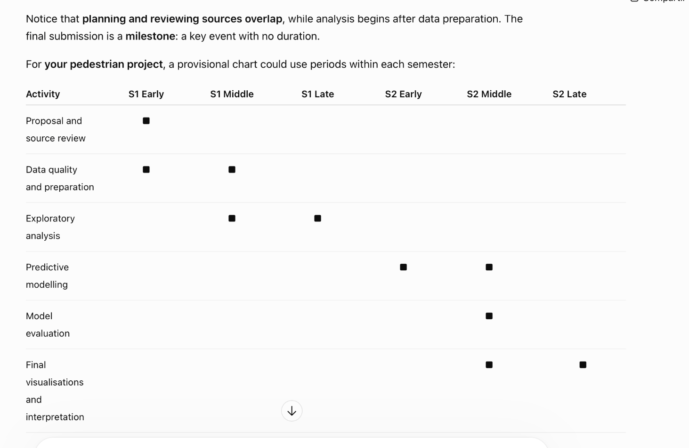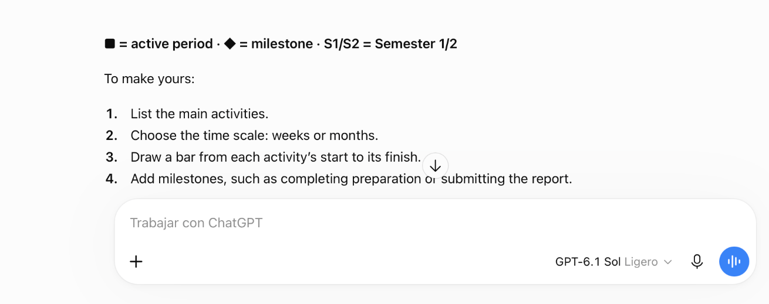

A3
AI tool: ChatGPT
Date: 14 October 2026
Purpose: To assess whether the dataset is suitable for a project spanning two semesters.
Exact prompt:
“I’ve checked the rows and columns (8760, 118) in the data I shared. do you think it's a good dataset for a one year project ?”
My evaluation and use:
The response explained that dataset dimensions alone do not establish suitability. It highlighted data quality, selecting reliable counters and the limitations of having only one year of observations. This helped me understand what must be assessed before finalising the selected locations.
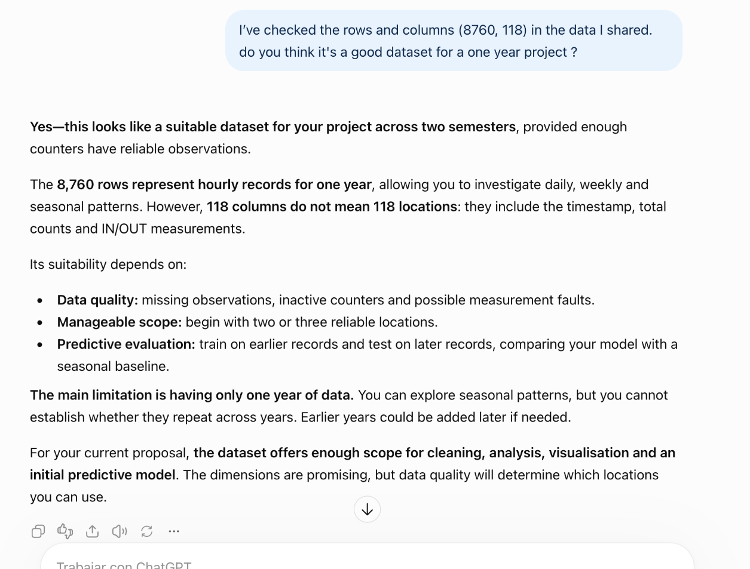
A4
AI tool: ChatGPT
Date: 14 October 2026
Purpose: To review and refine the project scope.
Exact prompt:
“I’ve put together this Scope. Does it look okay to you, or is there any part I should tweak?”
This project will focus on analysing historical pedestrian footfall data from Dublin City Centre to identify patterns across different locations, days and times. The project will include data cleaning, exploratory data analysis, visualisation and predictive modelling to estimate future pedestrian activity. The results will then be interpreted in relation to potential applications for retail and hospitality businesses, particularly staffing, promotions and stock planning.
The project will not include direct sales forecasting, individual customer behaviour analysis or individual customer tracking, as these variables are not available in the selected dataset. The project will focus on using pedestrian footfall as an indicator of potential customer traffic rather than directly measuring business performance.
Relevant AI output - Extract:
This project will analyse hourly pedestrian footfall data from 2025 at selected Dublin City Centre locations with sufficient data quality. It will include data cleaning, exploratory analysis, visualisation and predictive modelling. Findings will be interpreted in relation to potential staffing, promotion and stock planning applications for retail and hospitality businesses. The scope excludes direct sales forecasting, individual customer behaviour analysis and tracking. Footfall will indicate potential customer traffic rather than directly measure business performance.
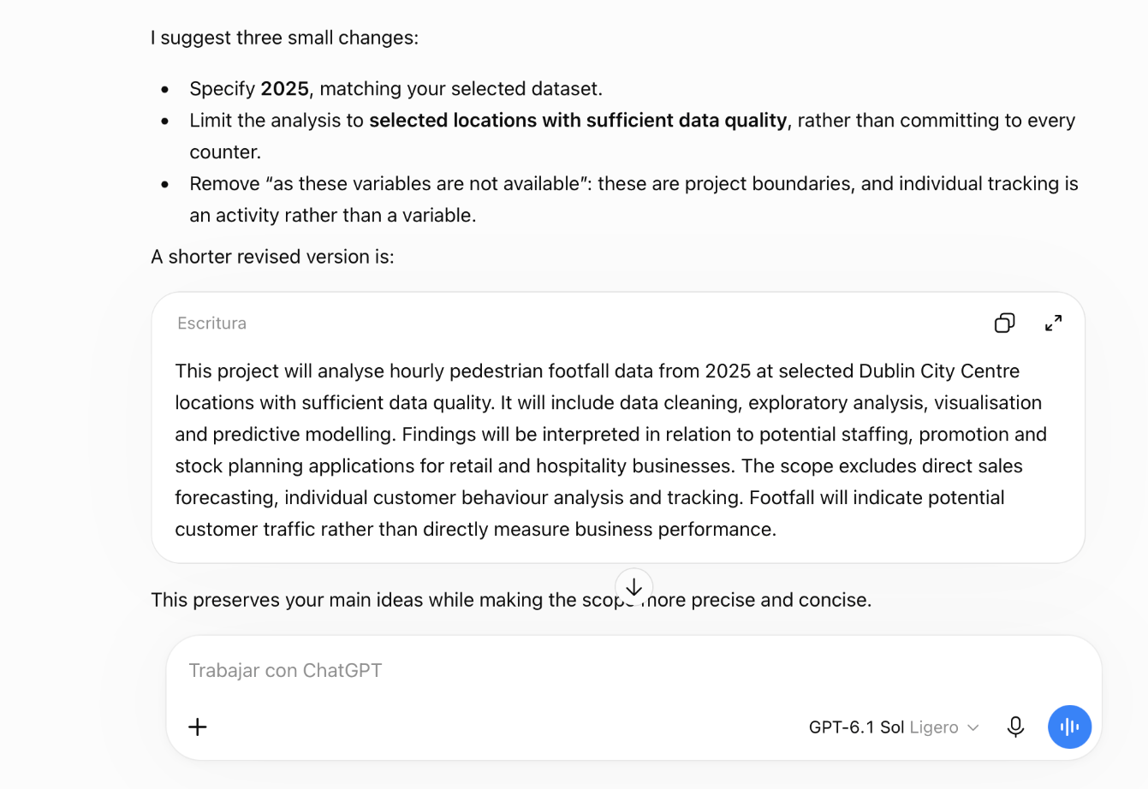
My evaluation and use:
I accepted the revised Scope because it specified the dataset year, limited the analysis to selected locations with sufficient data quality and clarified the exclusions. The revision preserved the potential business applications while distinguishing pedestrian footfall from actual business performance.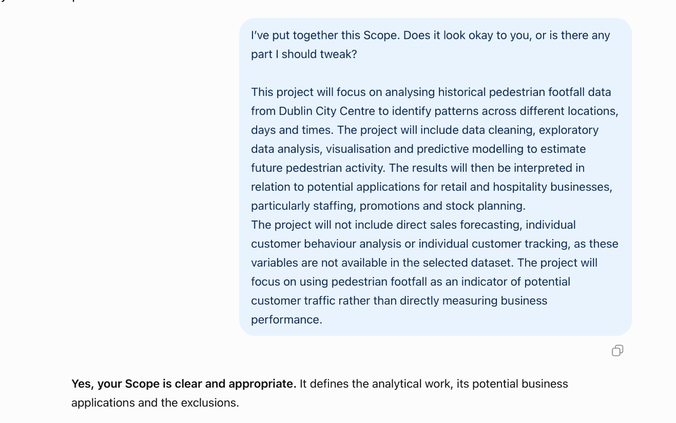
A5
AI tool: ChatGPT
Fecha: 18 October 2026.
Purpose: To learn how to create boxes and connectors for the project architecture diagram in Google Docs.
Exact prompt: I am making the architecture diagram for my project, but I don't know how to create the boxes to generate the diagram. I am working from google drive
Relevant AI output:
You can create the boxes using Google Docs’ Drawing tool:
- Open your document from Google Drive.
- Select Insert → Drawing → New.
- Click Shape → Shapes → Rectangle, then drag to draw a box.
- Double-click inside the box to type its label.
- Copy and paste the box to create the other stages.
- Use the Line dropdown to select arrows or connectors.
- Click Save and close to insert the diagram into your document. Google Docs Editors Help
Start with these three boxes arranged vertically:
- 2025 pedestrian footfall CSV
- Initial inspection
- Data preparation and counter selection
Connect them with downward arrows. Then add the analysis and modelling branches.
If Drawing is unavailable and your filename shows .DOCX, try File → Save as Google Docs, then open the converted copy.v
My evaluation and use:
I followed ChatGPT’s instructions to create the boxes and connectors for my architecture diagram in Google Docs. The guidance helped me use the drawing tool to represent the proposed project workflow.
